**Saturday 27th November 2021**

**10:00-12:30 and 15:00-16:00**

**One Day Creative Retreat**

*in Durham & Deerness Valley Methodist Circuit*



**Shadows and Light .**

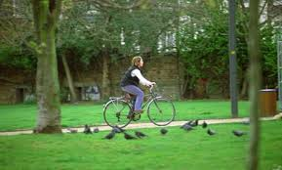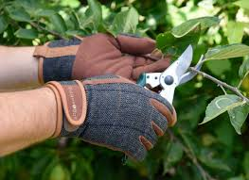

Come and join us for a day long retreat and quiet day. We hope that you will find a sense of fellowship, challenge and togetherness as we gather to share together in a combination of prayers and activities: some to challenge and some to help us relax and clear the mind and always to encourage us to come together as we set out on the journey through Advent. The day’s activities will explore the light and shade that is part of everyday life. We will think about moving towards the light as we move through Advent and towards Christmas. We will ask questions about stepping out of the shadows or ‘turning the torch on’ and seeing where God is at work in the shadows. We will face the challenge of how we might help and be helped by others journeying through life’s light and shade.

There will be space for personal engagement and reflection, as well as time to do the things you enjoy and the opportunity, if you choose, to do those things that just won’t wait.

A resource pack will be supplied to each participant along with a list of other useful items which might be readily found in your home. Please register to receive your resource pack and the *Zoom* link for the day: Sue Smith [susansmith0007@btinternet.com](mailto:susansmith0007@btinternet.com).

For further information: Anne Offler [anneoffler1@gmail.com](mailto:anneoffler1@gmail.com) ;

Deacon Ruth [DeaconRuthL@gmail.com](mailto:DeaconRuthL@gmail.com)