**Saturday 21st August 2021**

**10:00-12:30 and 15:00-16:00**

*in Durham & Deerness Valley Methodist Circuit*



**Come together .**

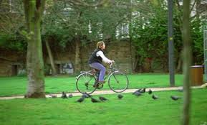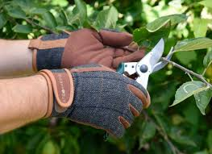

**One Day Creative Retreat**

Come and join us for a day long retreat and quiet day. We hope that you will find a sense of fun and fellowship as we gather to share together in a combination of prayers and activities: some to challenge and some to help us relax and clear the mind and always to encourage us to enjoy coming together in ways which have not been available to us in recent times. The day’s activities will explore different ways in which we can come together through song; craft and conversation; and around the table for *extended communion* and a picnic. We hope to offer the opportunity for groups of people to meet up for a part of the day or to remain at home gathered online: a hybrid retreat - blending the online and the physical.

There will be space for personal engagement and reflection, as well as time to do the things you enjoy and the opportunity, if you choose, to do those things that just won’t wait.

A resource pack will be supplied to each participant along with a list of other useful items which might be readily found in your home. Please register to receive your resource pack and the *Zoom* link for the day: Sue Smith [susansmith0007@btinternet.com](mailto:susansmith0007@btinternet.com).

For further information: Anne Offler [anneoffler1@gmail.com](mailto:anneoffler1@gmail.com) ;

Deacon Ruth [DeaconRuthL@gmail.com](mailto:DeaconRuthL@gmail.com)